1.Answer the questions (i) and (iii) after going through the following class:

4. Create a class called Box with a variable: width of type double. Inside the class

define a constructor and a friend that prints the width value(printWidth). In the

main() define a Box instance, set values and call printWidth.

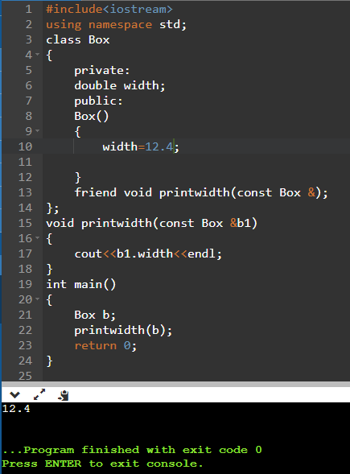

8. Write a program in C++ to calculate perimeter of all figures using the concept of

friend function.

